Http SAML Login enablement

- Launch the SAML 2.0 Configuration URL by using the t-code SAML2 from GUI.
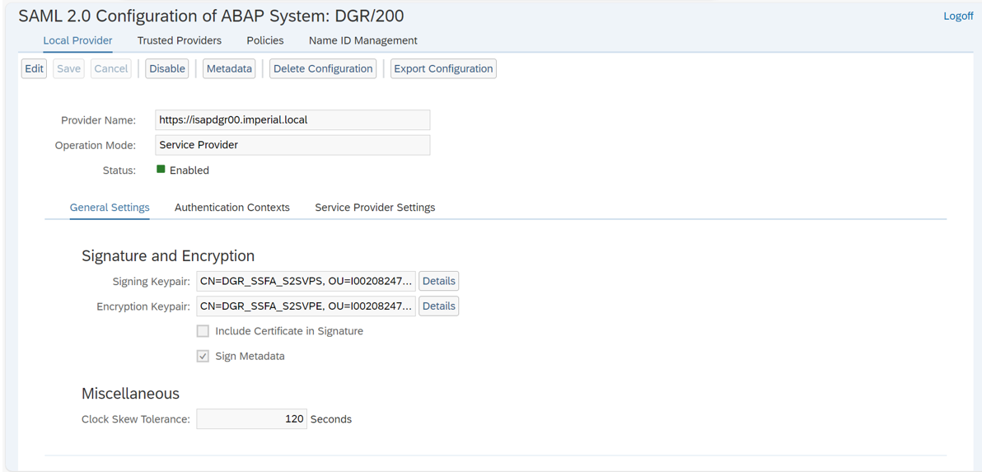

- Navigate to Trusted Providers tab and click on Add.
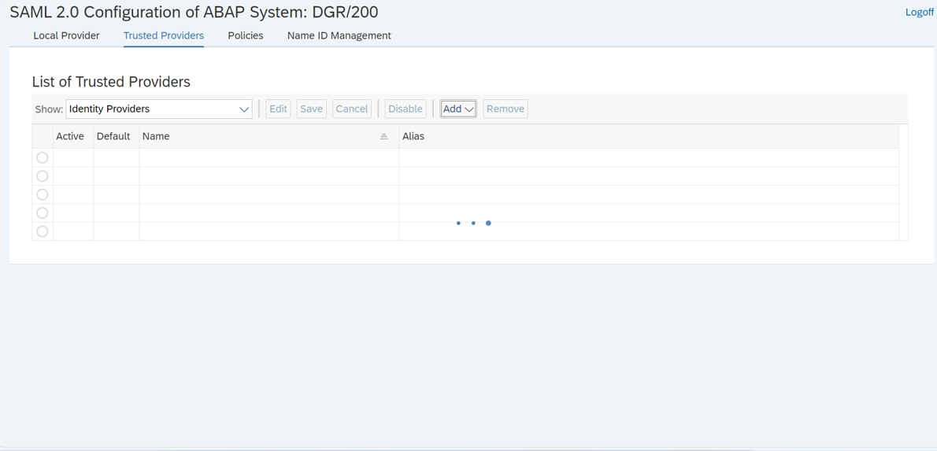

- Select the signed Metadata .xml file provided from DP World Team.
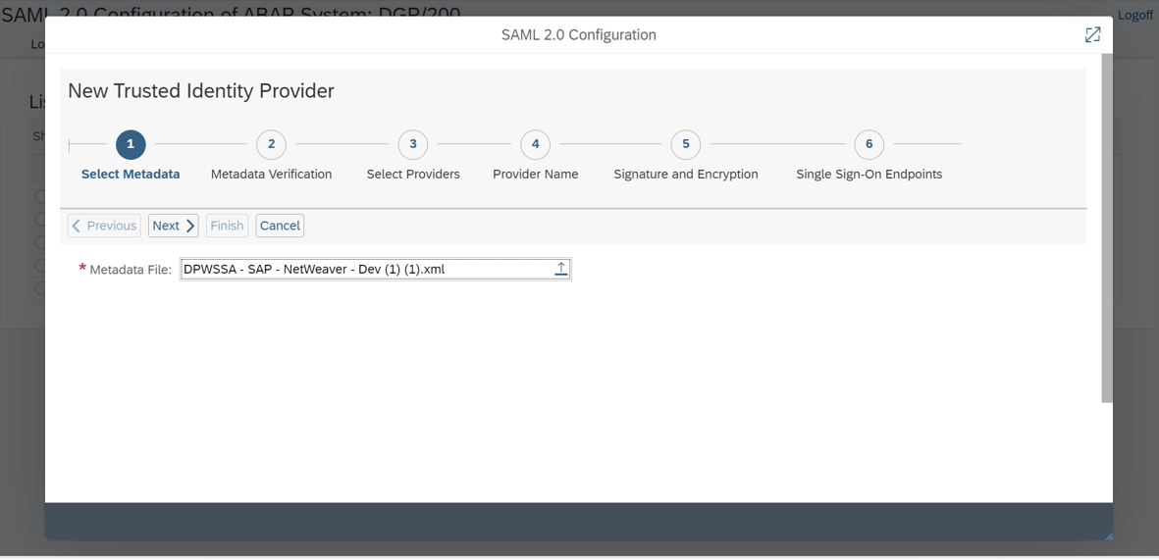

- Send a mail to DP world team with meta data file of new configuration and get it signed.

- In the Step 2 i.e. Metadata Verification upload the copy of signed certificate provided from DP World Team.
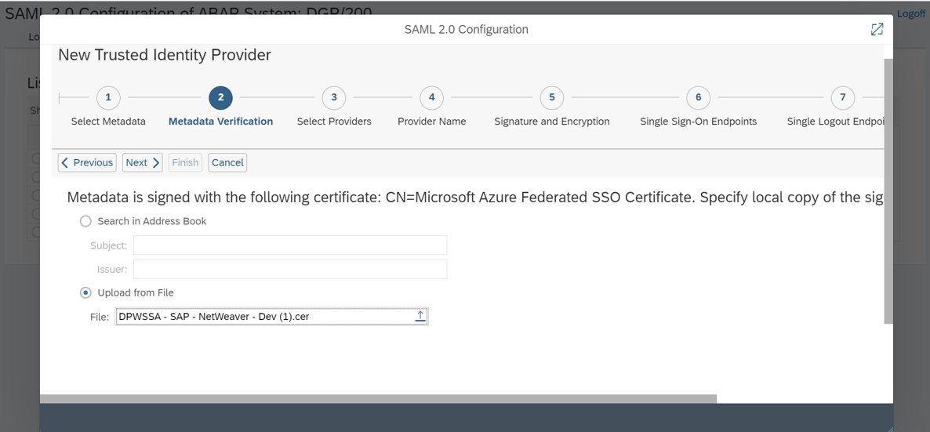

- Select the required Providers.

- Mention the name of the Provider i.e. “https://sts.windows.net/2bd16c9b-7e21-4274-9c06-7919f7647bbb/”.
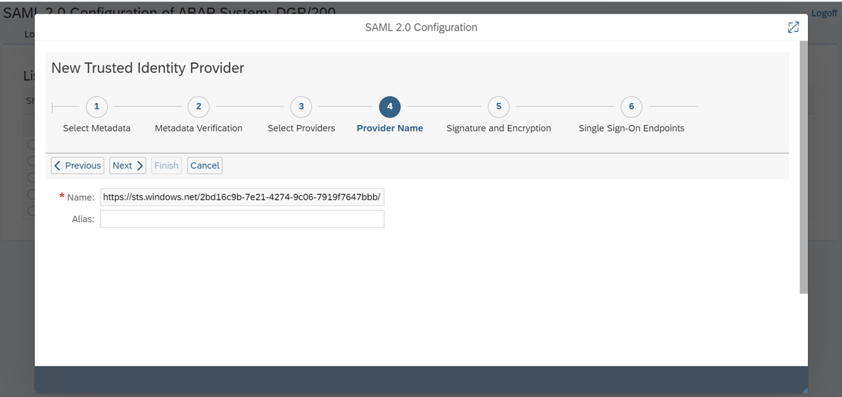

- Select the Primary Signing Certificate as CN=Microsoft Azure Federated SSO Certificate.
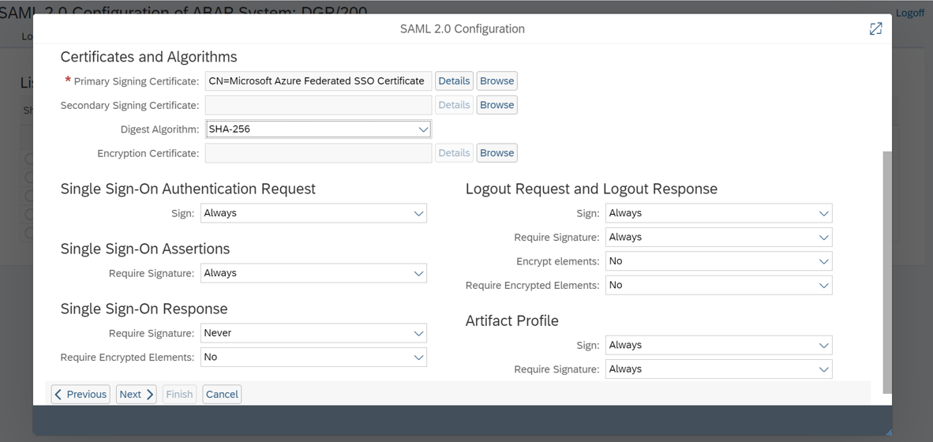

- Select Single Sign-On Endpoints.
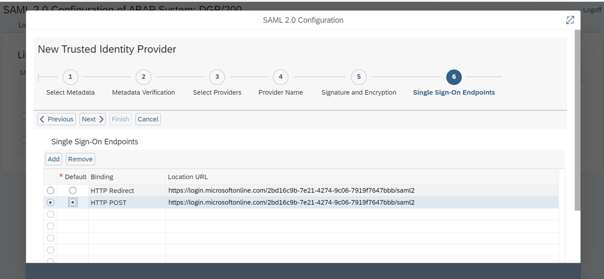

- Select the Single Logout Endpoints.
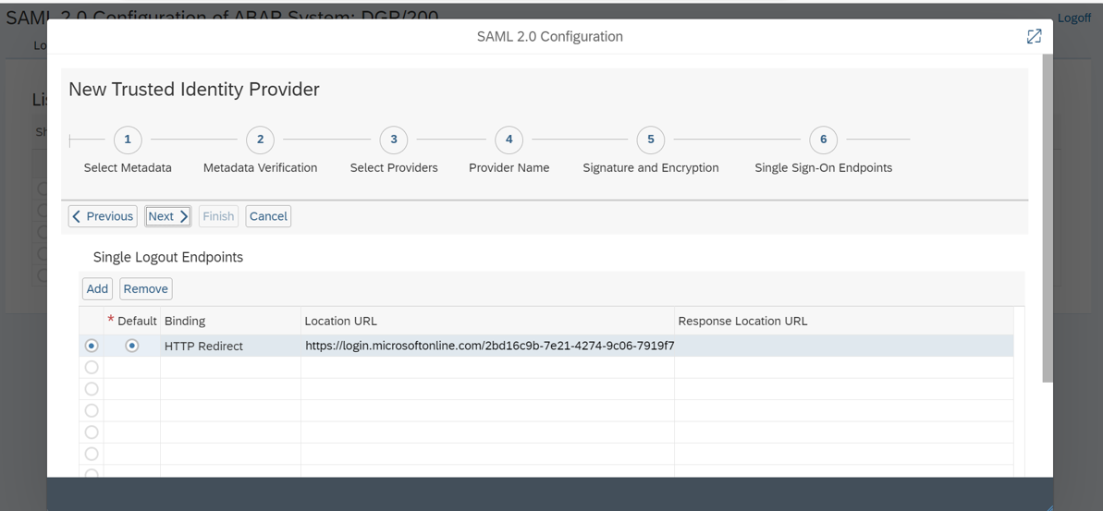

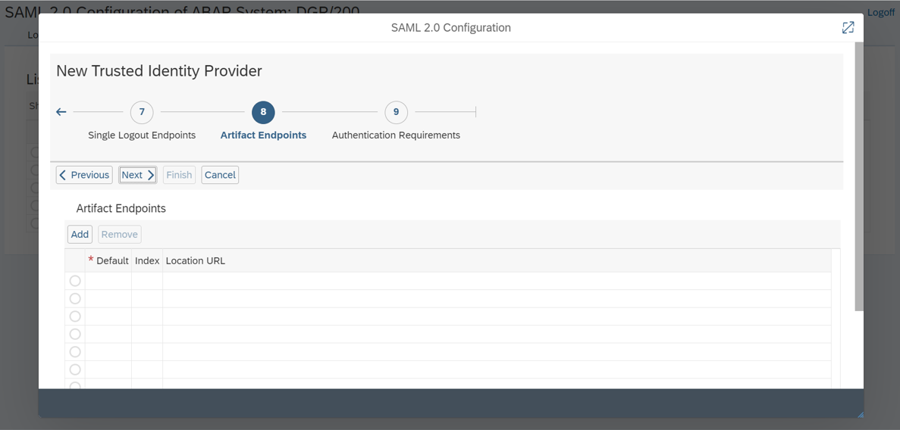

- Click on Finish.
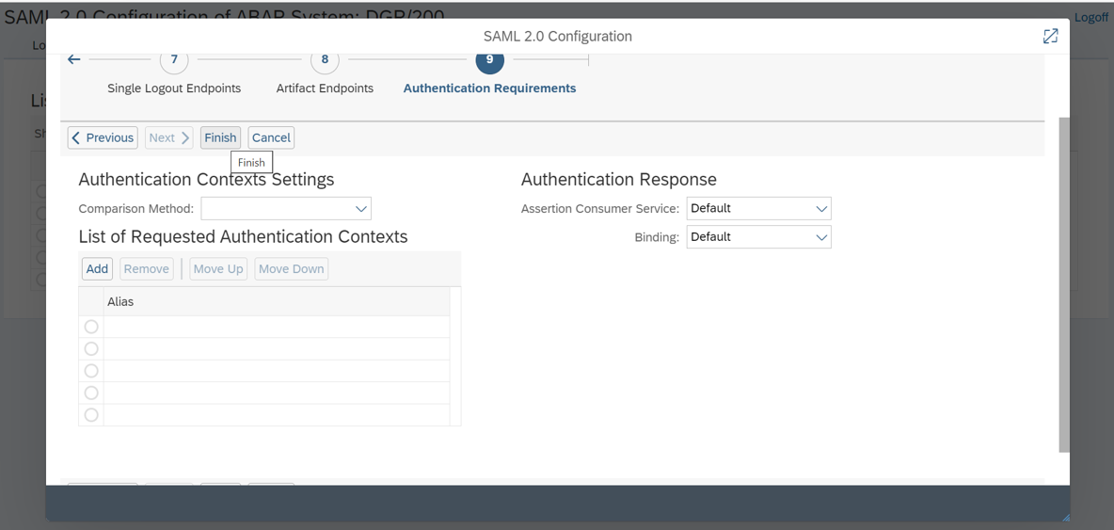

- In Identity Federation tab select Supported NameID Formats as Unspecified.
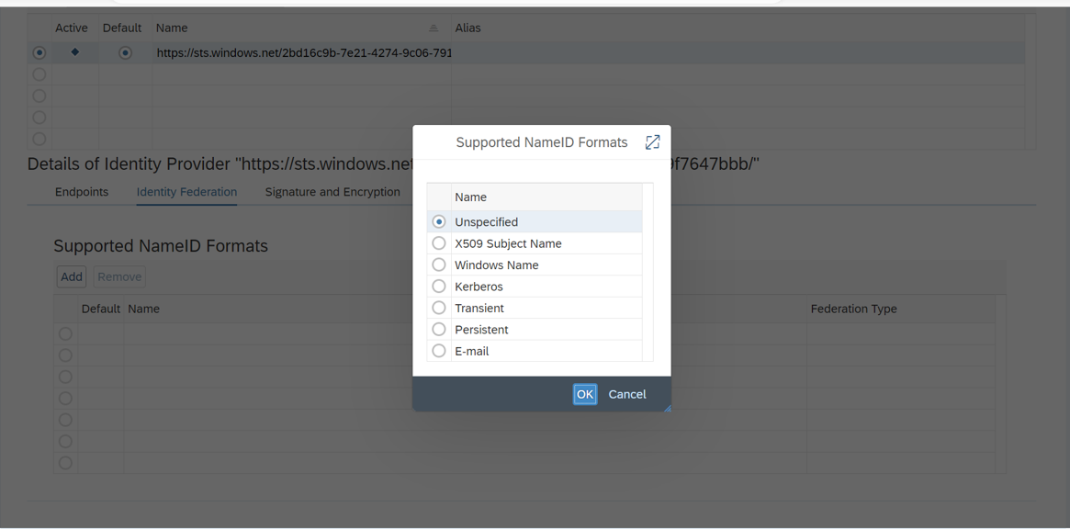

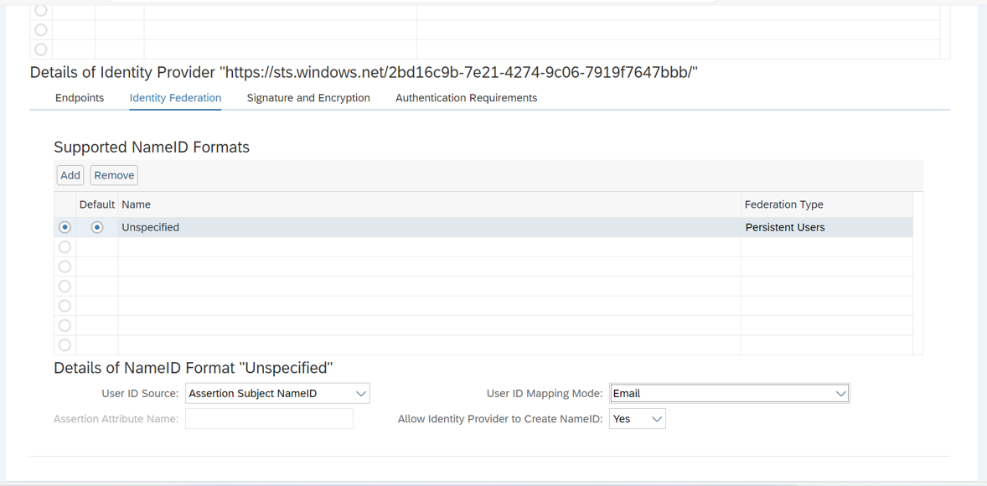

- Upgraded SAP Business Client from 7.70 PL29 to 8.00 PL9.
https://launchpad.support.sap.com/?sap-ui-language=en-US&sap-ui-theme=sap_fiori_3&help-theme=horizon

- Activated the nwbc_api service at default_host -> sap -> bc -> ui2 -> nwbc -> nwbc_api to redirect the URL https://isapdgr00.imperial.local/nwbc/TicketIssuer internally to https://isapdgr00.imperial.local/sap/bc/ui2/nwbc.
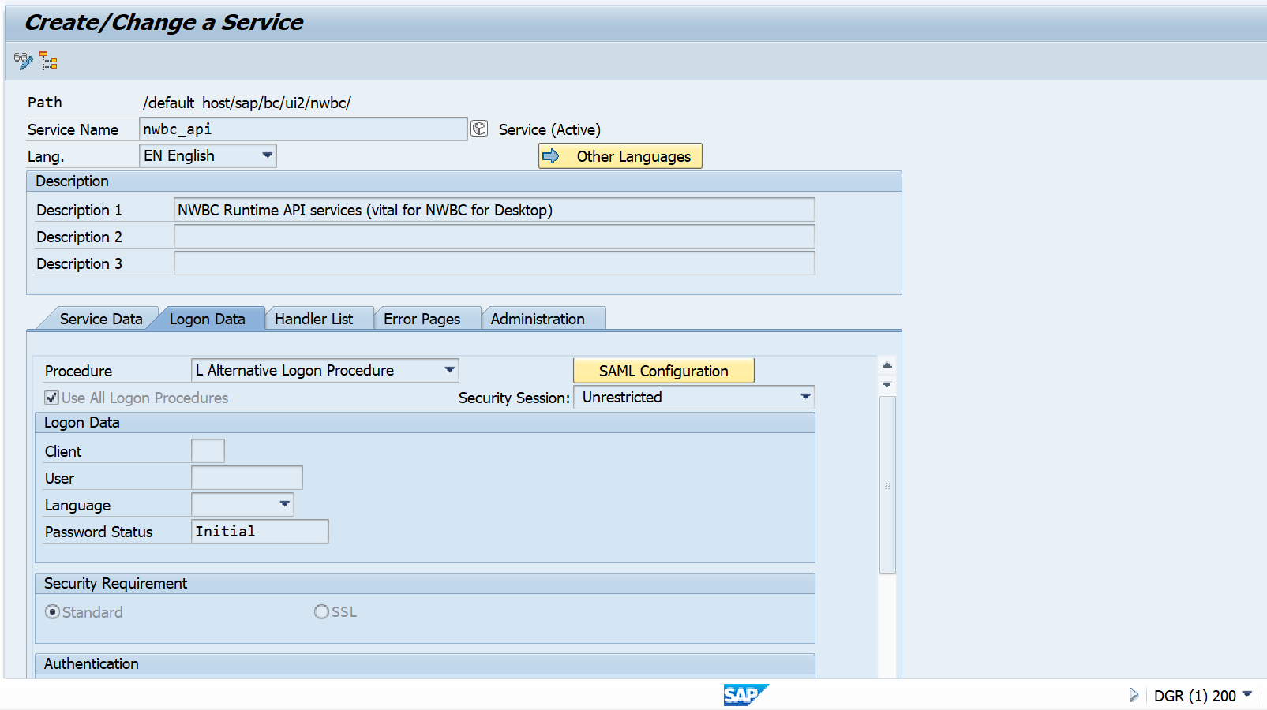

- Change the Logon procedure list (in Order of execution) in the logon Data tab.
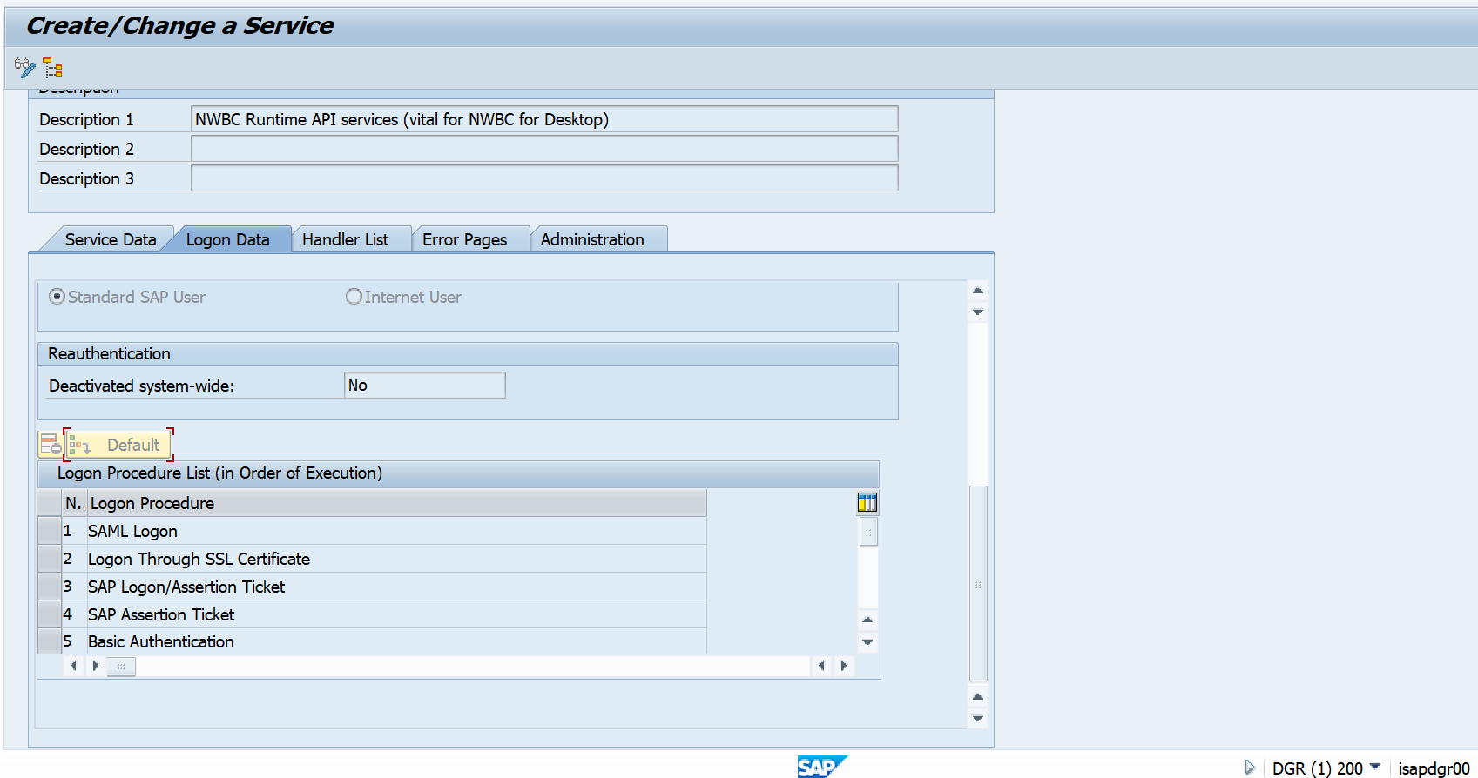
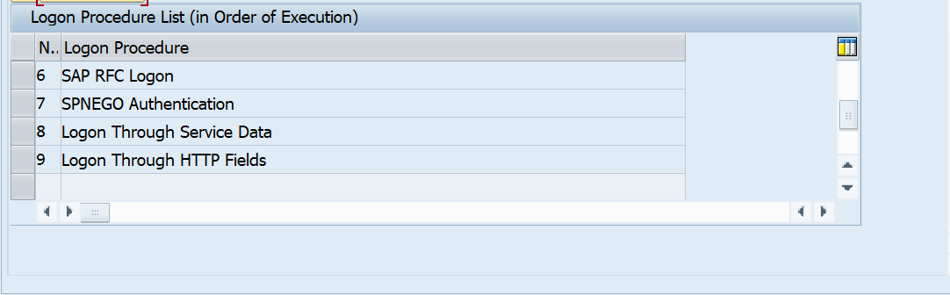

- Launch the NWBC page by using the t-code nwbc from GUI.
